**Assignment-1**

**Home Automation using tinkercad**

|  |  |
| --- | --- |
| Assignment Date | 19 September 2022 |
| Student Name | M.G.Shalini Devi |
| Student Roll Number | 910619104075 |
| Maximum Marks | 2 Marks |

**Question-1:**

Home automation using Tinkercad.

**Solution:**

**// C++ code**

**#include <Servo.h>**

**int sensor_state = 0;**

**int distance = 0;**

**long readUltrasonicDistance(int triggerPin, int echoPin)**

**{**

**pinMode(triggerPin, OUTPUT); // Clear the trigger**

**digitalWrite(triggerPin, LOW);**

**delayMicroseconds(2);**

**// Sets the trigger pin to HIGH state for 10 microseconds**

**digitalWrite(triggerPin, HIGH);**

**delayMicroseconds(10);**

**digitalWrite(triggerPin, LOW);**

**pinMode(echoPin, INPUT);**

**// Reads the echo pin, and returns the sound wave travel time in microseconds**

**return pulseIn(echoPin, HIGH);**

**}**

**Servo servo_3;**

**void setup()**

**{**

**pinMode(2, INPUT);**

**servo_3.attach(3, 500, 2500);**

**pinMode(7, OUTPUT);**

**pinMode(A2, INPUT);**

**}**

**void loop()**

**{**

**distance = 0.01723 * readUltrasonicDistance(5, 4);**

**sensor_state = digitalRead(2);**

**servo_3.write(0);**

**// if sensor_data is high, rotate servo motor, else**

**// close it.**

**if (sensor_state == HIGH) {**

**servo_3.write(45);**

**servo_3.write(0);**

**delay(4000); // Wait for 4000 millisecond(s)**

**servo_3.write(0);**

**tone(7, 123, 1000); // play tone 35 (B2 = 123 Hz)**

**}**

**if (distance <= 100) {**

**servo_3.write(80);**

**tone(7, 123, 1000); // play tone 35 (B2 = 123 Hz)**

**delay(4000); // Wait for 4000 millisecond(s)**

**servo_3.write(0);**

**} else {**

**servo_3.write(0);**

**}**

**if (analogRead(A2) > 350) {**

**servo_3.write(90);**

**tone(7, 220, 10000); // play tone 45 (A3 = 220 Hz)**

**servo_3.write(0);**

**}**

**}**

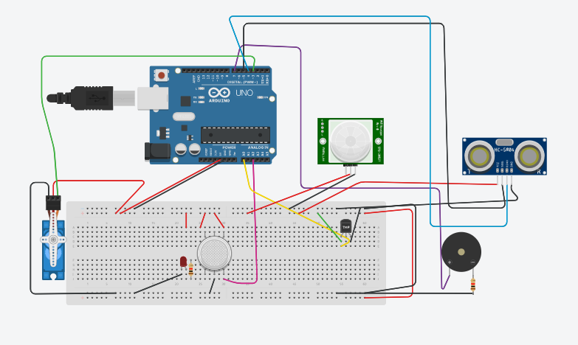

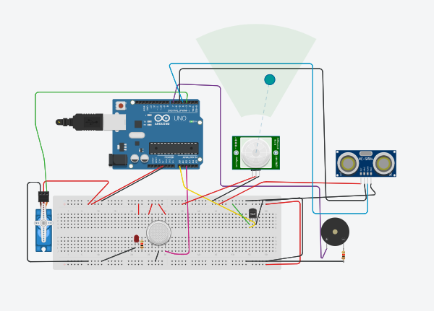

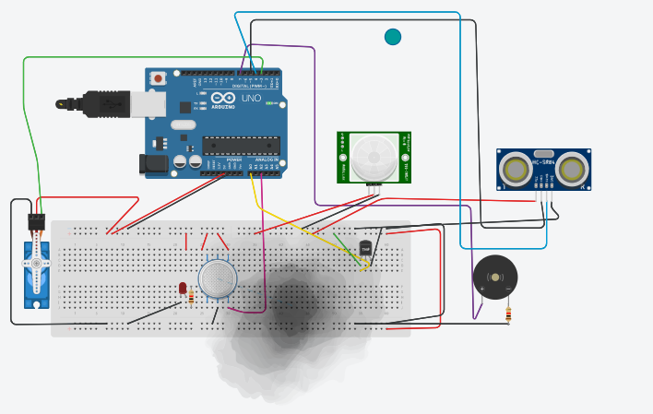

LINK OF TINKERCAD:<https://www.tinkercad.com/things/3hpHJMswZow-automation/editel>